Name of Grantee: [Name]

Grant amount: $[Amount]

**ARTS COUNCIL OF NEW ORLEANS**

**Community Arts Grants**

**New Orleans as Cultural Capital**

**2023 Letter of Agreement**

As 2023 recipient of the Community Arts Grants program, the grantee listed agrees to:

1. Use grant funds of to cover expenditures for programs and services from January 1 - December 31, 2023, as described in the Scope of Services attached hereto; and

2. Report to Arts New Orleans immediately concerning any changes in “Scope of Services” or “Revised Budget”; and

3. Acknowledge Community Arts Grants support by using the City of New Orleans’ and Arts New Orleans’ logos following credit line on all publications and programs:

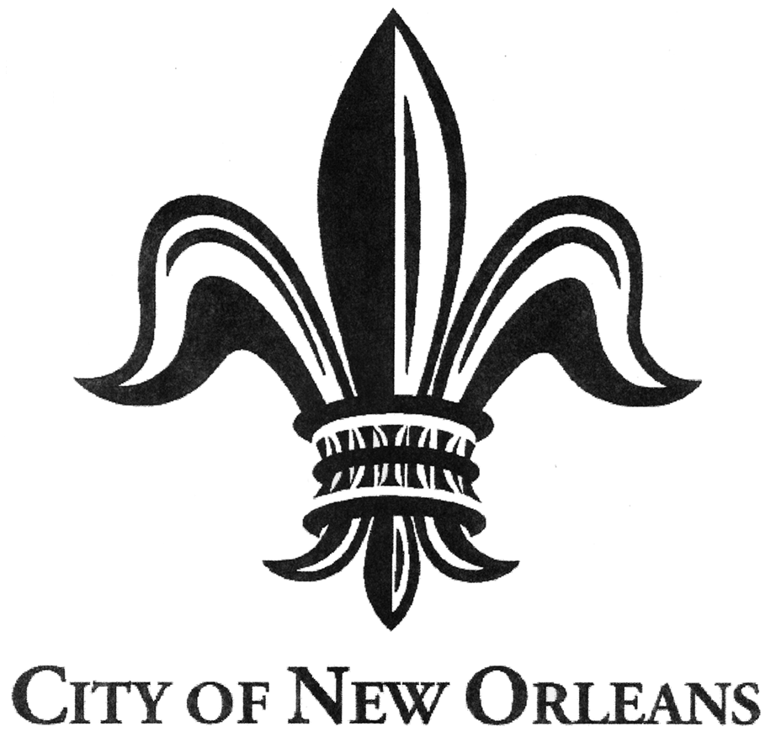

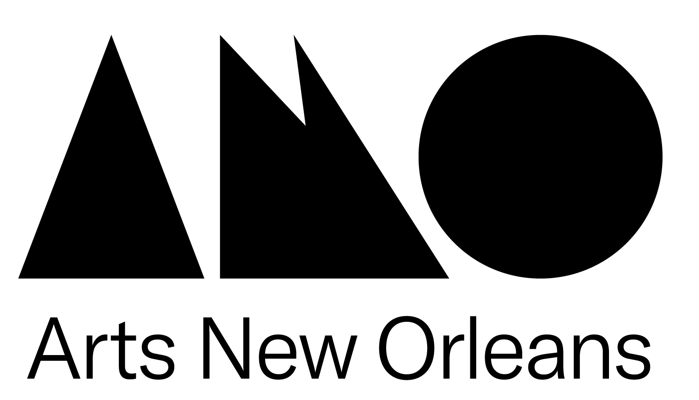This program is supported in part by a

Community Arts Grant made possible

by the City of New Orleans as administered

by Arts New Orleans

4. Inform Arts New Orleans and City officials on a regular basis concerning progress in programs and services through press releases, brochures or programs; and

5. Provide Arts New Orleans with at least two complimentary tickets if a program is not free to the public so that Arts New Orleans staff may attend funded programs; and

6. Submit a final report including all required attachments and on the designated form to Arts New Orleans within thirty-one (31) days after the completion of grant activity period, no later than January 31, 2024. Failure to do so may render recipient ineligible to receive the full final payment of the grant award. Recipients in noncompliance may also be asked to return some or all of its initial grant payment. For a year following a determination of noncompliance, the grantee will be ineligible to receive any new grants.

7. Retain all of its records and supporting documentation applicable to this letter of agreement with Arts New Orleans for a period of three years, and make all such records and supporting documentation readily available upon request, for inspection or audit by representatives of Arts New Orleans; and

2023 CAG Letter of Agreement

8. Prohibit political activity. None of the funds provided by the Community Arts Grants program shall be used for any partisan political activity, or to further the election or defeat of any candidate for public office.

9. Understand that Community Arts Grants are contingent upon Arts New Orleans’ receipt of City funds.

EXECUTIVE DIRECTOR OR OTHER AUTHORIZING OFFICIAL

Signature _____________________________________________

Typed Name

Title

Date

Phone

Email

SECOND AUTHORIZING OFFICIAL

Signature _____________________________________________

Typed Name

Title

Date

Phone

Email

**ARTS COUNCIL OF NEW ORLEANS**

**COMMUNITY ARTS GRANTS**

**Funding Period: January 1 - December 31, 2023**

**Category: New Orleans as Cultural Capital**

**Scope of Services Form**

**Provide a summary of arts activities that are part of your general operations taking place January through December in 2023. Include artists/groups to be hired, locations of activities, and dates.**

**ARTS COUNCIL OF NEW ORLEANS**

**COMMUNITY ARTS GRANTS**

**NEW ORLEANS AS CULTURAL CAPITAL**

**2023 REVISED BUDGET**

**Review the budget in your original proposal. This revised budget should indicate only how Community Arts Grant funds will be spent. Please use the Additional Cash line below to show total funds (excluding this grant) raised by the organization during the calendar year in which grant funds will be used.**

**Personnel - Administrative**

**Personnel - Artistic**

**Personnel - Technical**

**Utilities**

**Outside Artistic Fees**

**Outside Other Fees**

**Space Rental**

**Travel**

**Marketing/Printing**

**Equipment Rental**

**Supplies and Materials**

**Postage**

**Insurance**

**Shipping**

**Other (specify) _________________________**

**______________________________________**

**Total Grant Expenditures $** [Amount]

**Additional Cash**

**TOTAL CASH BUDGET**